Steps for Execution

1. Vuforia
   1. Create an account on Vuforia Developer Portal 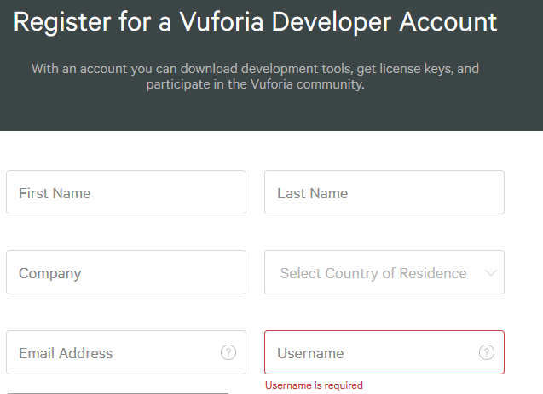
   2. Login into Vuforia Developer Portal

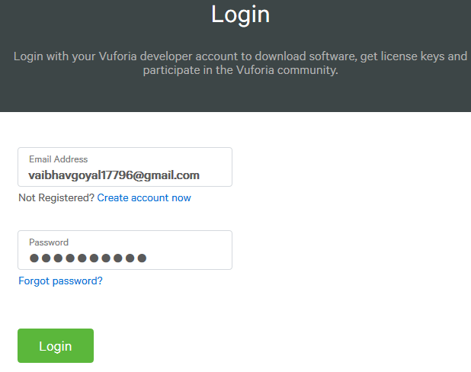

* 1. Create a License Key to be used in Unity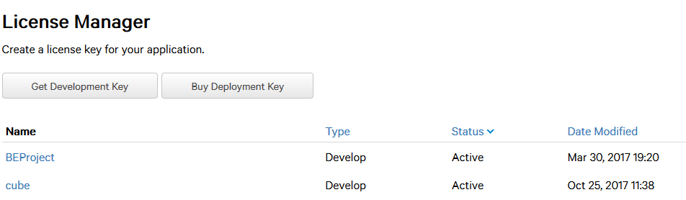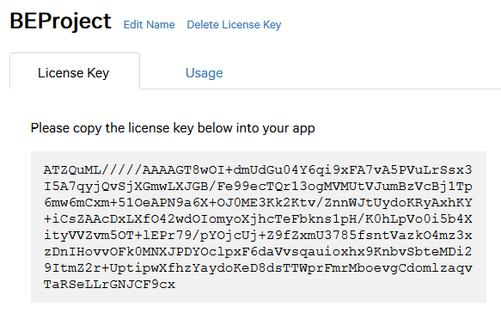
  2. Create a database to store the image targets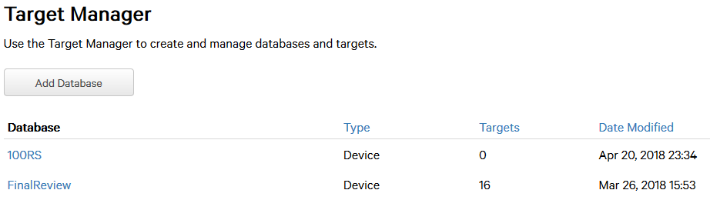
  3. Add image target in Target Manager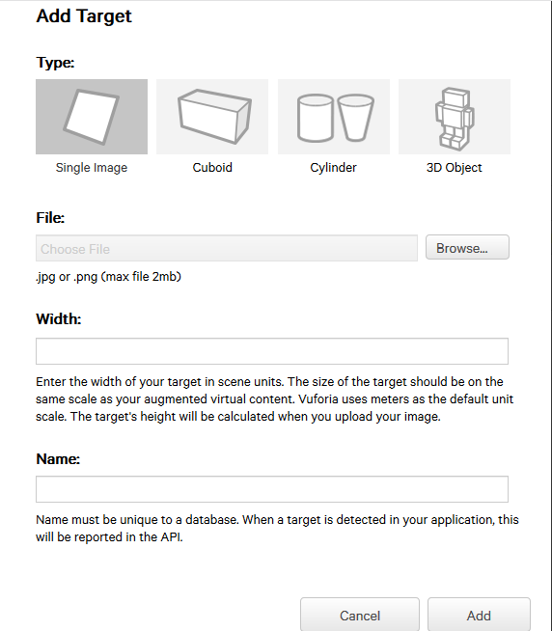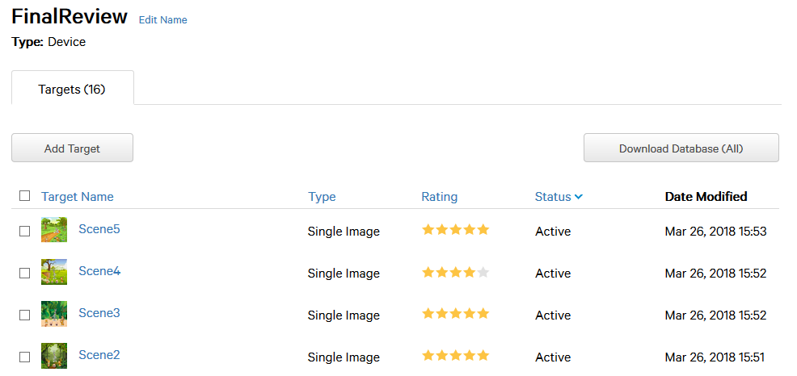
  4. Download all the image targets from database as Unitypackage to be imported into Unity software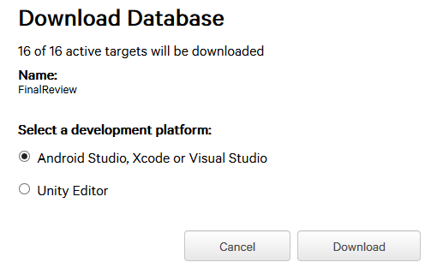

1. Unity
   1. Sign Up or Login into Unity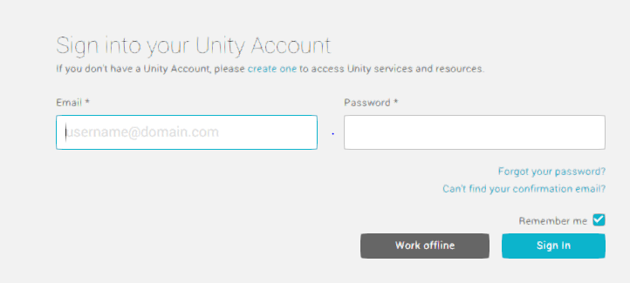
   2. Create a new Unity Project or open open an existing project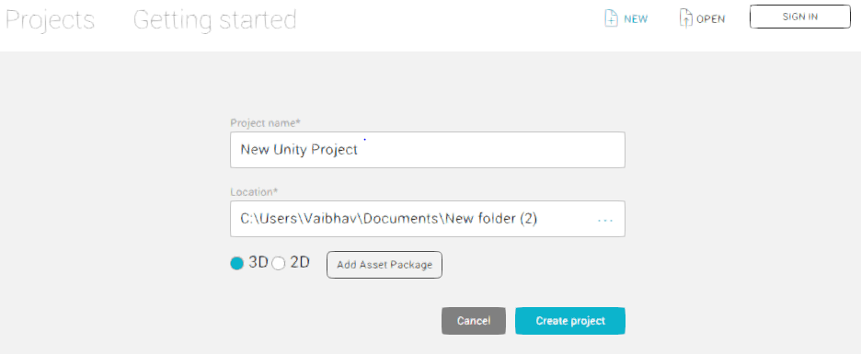
   3. Import Assets as unitypackage into Assets Manager. These assets include unitypackage from Vuforia which contains Image Targets, Vuforia Configuration, 3d models, audio files etc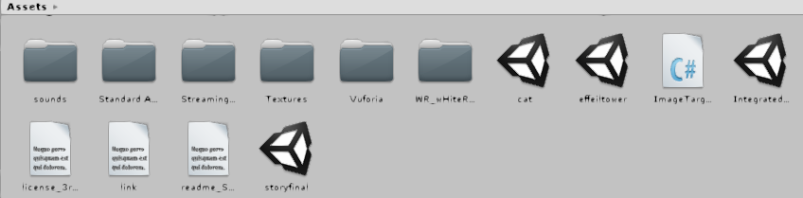
   4. Place all the required assets into the screen space of a scene and

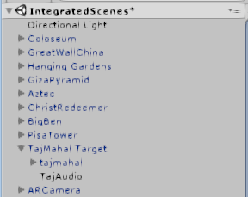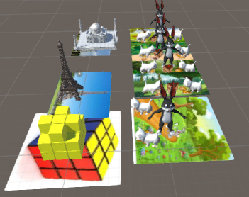

* 1. Configure the Vuforia settings for AR Camera

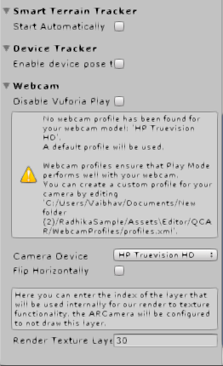

* 1. Enter the game mode and check if 3d model is projected when the Image target is detected 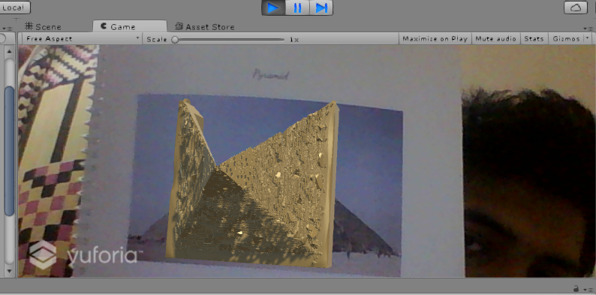
  2. Create android application after proper configuration in Build settings in File tab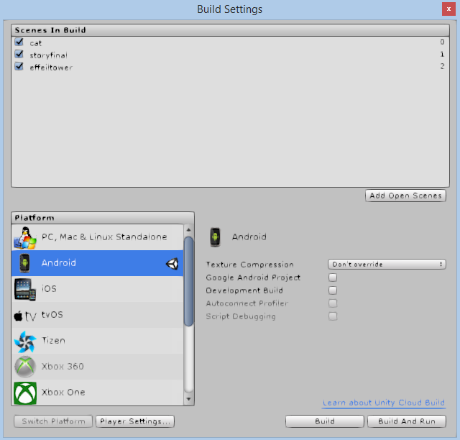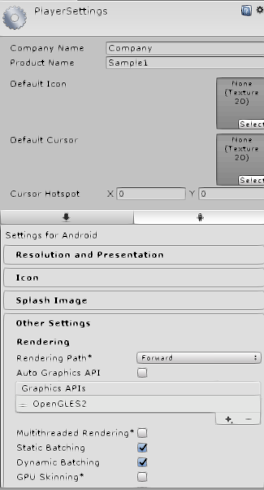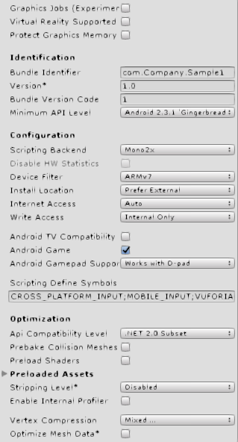

1. Exploration(Android Application)
2. Open the Android Application Exploration

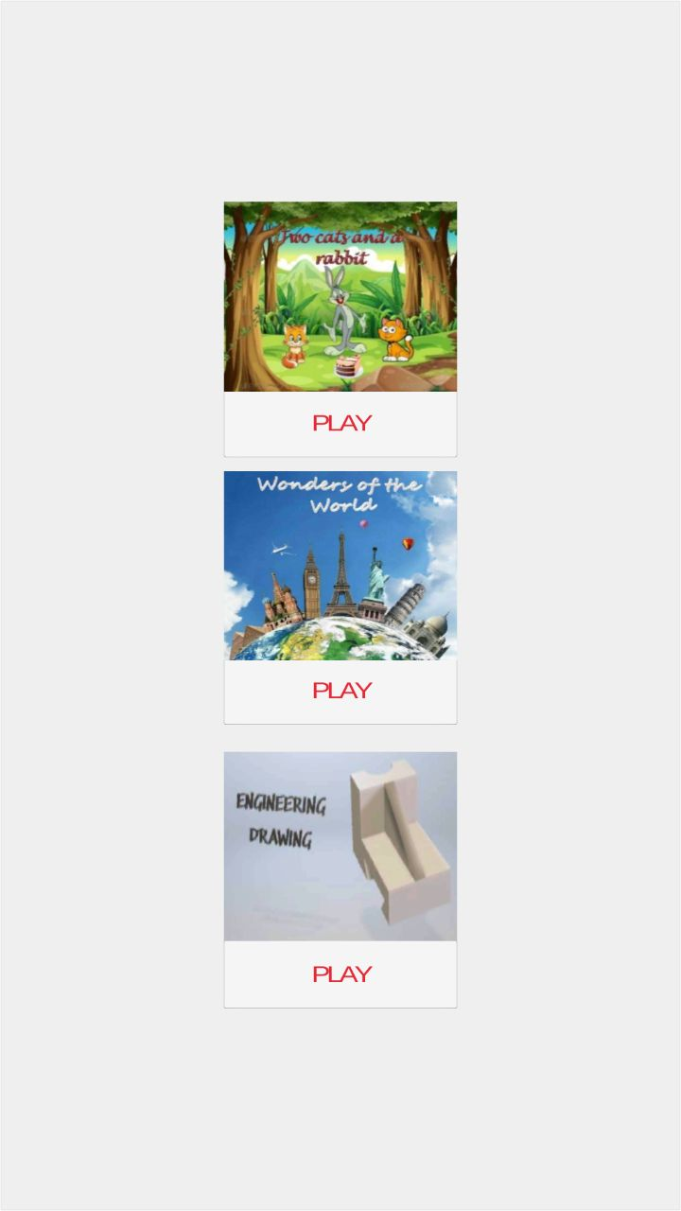

b. Select the scene you want to play .

Scene 1 - Story telling

Scene 2 - Wonders of World

Scene 3 - Engineering Drawing

c. Animated characters 3D model are projected onto the real world when Image target

is detected . User can return to the welcome screen anytime during the playtime by

clicking the “BACK” button.

Story Telling -

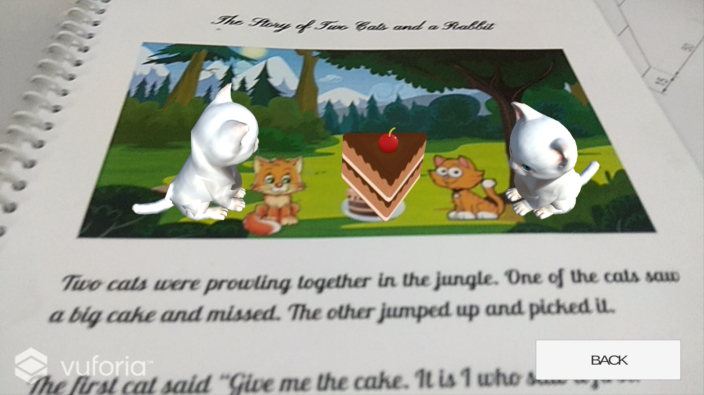

Wonders of world -

## 

Engineering Drawing -

## 